20 launches a year to 2012
Space tourism a valid market by 2021

By Chris Forrester

Futron’s latest market study (Analysis of Space Concepts Enabled by New Transportation ASCENT, April 10), supplies on the one hand an optimistic and encouraging suggestion of new markets for space utilisation (see table). Equally impressive, especially in terms of the current moribund satellite launch sector, Futron suggest that typically the market will demand an average of about 20 launches per year between now and 2012. However, Futron also suggest that Space Tourism, despite the obvious risks, will become a buoyant market in the decade following 2012.

“While the trend in the overall launch forecast is fairly flat, several individual markets experience more pronounced trends. For the Existing Commercial Markets (Telephony, Television/Radio, Data Communications, On-orbit Sparing, and Commercial Remote Sensing), the outlook hovers around 20 launches a year globally until around 2012, when there is an increase due to the replenishment of a number of satellites. After a few years of higher-than-average launches, the demand for Existing Commercial Markets returns to the previous average of around 20 launches a year,” says Futron’s White Paper.

Futron suggest there will be a gradual decline in launch demand from Government Markets, from a high of over 60 to less than 40 launches per year. While there are many factors contributing to this overall decline (the Government Sector forecast includes launch requirements from all space-faring and near-space-faring nations and 13 individual markets), sizable decreases are seen in non-ISS space science missions and Russian military launches. Additionally, government-sponsored launch activity will during this period fall from around 75% of the overall total to 50%, and by 2021 have achieved 50/50 parity between military and commercial launch activity.

One dramatic increase in launch activity is suggested by Futron: public space travel. The report states that Evolving market activity will become increasingly important to the launch industry, and that public space travel could account for 10 of the 14 launches in 2021. This forecast is outside the NASA-funded study and emerged from Futron’s own additional research studies. They state that public space travel, despite being derided by current industry professionals, remains a “real and robust” market. Futron’s examination looked at affluent Americans, being the segment of the population most able to fund a trip into space.

Some 450 millionaires were surveyed and the hazards of such a trip explained. Futron developed a public space travel forecast for the ASCENT Study assuming a US$20m price tag for launch on a Russian Soyuz, the only vehicle currently capable and available to provide public space travel services. Even with all the constraining factors (i.e., limited supply, relatively high price, long training times in Russia), Futron are happy to suggest a growing market for public space travel beginning in 2011 (2 launches) and growing to a 10 annual launch status by 2021.

Futron’s report takes on the chin the obvious risks associated with space travel. The challenge, says Futron, is for the aerospace industry is to develop a vehicle that can cost-effectively meet this demand. “The company that ultimately meets this challenge may come from the X-Prize competition; it may be a traditional aerospace company (perhaps leveraging some OSP-developed technology); or it may come from a company not based in the United States (this last option is becoming more and more likely). However, regardless of where the company comes from or how it meets the challenge, the demand for the public space travel is real, robust, will eventually make someone very wealthy, and is one of the few areas where growth can be predicted for the launch industry.”

One other fascinating set of numbers to emerge from Futron’s work is the launch cost in terms of different market areas (see table). However, one potential new product, that of the much-talked about Re-usable Launch Vehicle (RLV) has the ability to dramatically influence launch costs and the number of launches per annum. “Currently, the business case for the RLV remains unproven because of the unknown development costs to produce the vehicle. However, such considerations do not detract from the fact that if an RLV could be produced, anywhere in the world, there would be a need for a major reassessment of the offerings and prices within the ELV industry,” says Futron.

[Box This]

Futron’s Aggregated Launch Forecast for All ASCENT Study Markets*
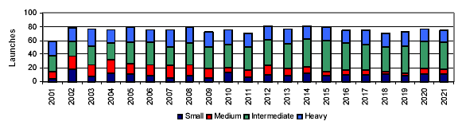
Data: Futron Corp. April 2003

[Close box]

[Box This]

Current Launch Price per Pound by Market Sector (in 2001 dollars)*
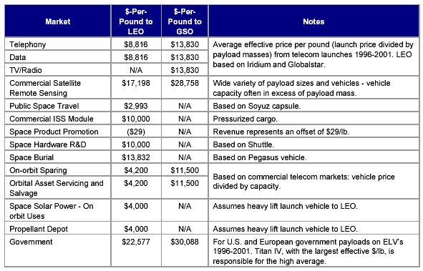
*Data: Futron Corp

754 + tables

